IBM DATA SCIENCE NOTES

WHAT IS DATA SCIENCE?

- Data science is the study of large quantities of data, which can reveal insights that help organizations make strategic choices.

- New data scientists need to be curious, judgmental and argumentative.

- Professor Rajan is an engineer. So are Xi Jinping, the President of the People’s Republic of China, and Alexis Tsipras, the Greek Prime Minister who is forcing the world to rethink the fundamentals of global economics. They might not be designing new circuitry, distillation equipment, or bridges, but they are helping build better societies and economies and there can be no better definition of engineering and
engineers—that is, individuals dedicated to building better economies and societies.

- Exploratory Data Analysis or (EDA) is understanding the data sets by summarizing their main characteristics often plotting them visually. This step is very important especially when we arrive at modeling the data in order to apply Machine learning.
- Data science - An interdisciplinary field that combines scientific methods, processes, algorithms, and systems to extract knowledge and insights from structured and unstructured data.

DATA SCIENCE METHODOLOGY

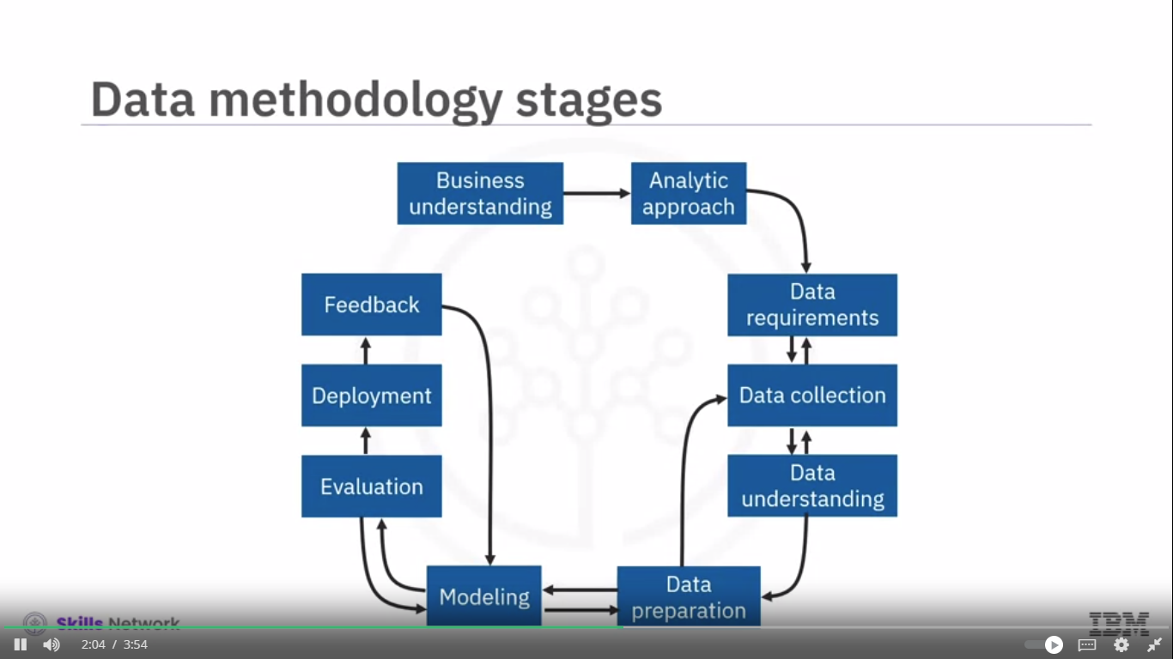

- That its purpose is to explain how to look at a problem, work with data in support of solving the problem, and come up with an answer that addresses the root problem.

- Data science model The result of data analysis and modeling that provides answers to specific questions or problems.

- So, if the problem that needs to be resolved is the recipe, so to speak, and data is an ingredient, then the data scientist needs to identify: which ingredients are required, how to source or to collect them, how to understand or work with them, and how to prepare the data to meet the desired outcome.

Data Requirements:-

  - Identify Data requirements for the Analytical approach selected. Initial Data collection is done for requirement fulfillment at this stage.

Data Collection:-
- After the initial data collection is performed, an assessment by the data scientist takes place to determine whether or not they have what they need.

- Gaps in data will be identified and plans to either fill or make substitutions will have to be made.

- It is alright to defer decisions about unavailable data, and attempt to acquire it at a later stage.

Data integration:-

  - The merging of data from multiple sources to remove redundancy and prepare it for further analysis. This is a part of Data Preparation Stage. This part is done by DBAs and Programmers.

Data Understanding:-

  - The Data Understanding stage encompasses all activities related to constructing the data set and answers the question as to whether the data you collected represents the problem to be solved.

  - EDA(Exploratory Data Analysis) is also done at this stage.

Data Preparation:-

- The process of organizing and formatting data to meet the requirements of the modeling technique.

- This is one of the most time-consuming phase of the Data Science Project. Automating some of the Data collection and Preparation processes in the DB can reduce this time. Use the tools available to automate common steps to accelerate Data Preparation.

- Feature engineering, also part of the Data Preparation stage, uses domain knowledge of the data to create features that make the machine learning algorithms work.

- Text analysis during the Data Preparation stage is critical for validating that the proper groupings are set and that the programming is not overlooking hidden data.

- This is one of the most important step in the Data Science so take your time here.
- Pay attention to detail.

Modelling:-

- Data Modelling focuses on developing either descriptive or predictive models.

- These models are based on Analytical Approach taken, they can be either statistically driven or machine learning driven or both.

- For Predictive Modelling, Data Scientist uses a training set which acts like a calibration gauge for the model.

- Data Scientists play around with different algorithms to ensure that the variables in play are actually required.

- New Data Science Topics learnt:

- Confusion Matrix
- Specificity and Sensitivity
- ROC and AUC
- Cross Validation

Model Evaluation:-

- Model Evaluation goes hand-in-hand with model building as such that Model Evaluation and Model Building are both done iteratively.

- It assess the quality of the model and ensures whether the model really answers the initial question or not.
- Model Evaluation has 2 phases:

- Diagnostic Measures phase

- If model is a predictive model, a decision tree can be used to determine if the answer the model can output is aligned to initial design.

- If the model is a descriptive model, one in which relationships are being assessed, then a testing set with known outcomes can be applied, and the model can be refined as needed.

- Statistical Significance Testing

      - This type of evaluation can be applied to the model to ensure that the data is being properly handled and interpreted within the model. This is designed to avoid unnecessary second guessing when the answer is revealed.

Model Deployment:-

- Once the model is evaluated and the data scientist is confident it will work, it is deployed and put to the ultimate test.
- Depending on the purpose of the model, it may be rolled out to a limited group of users or in a test environment, to build up confidence in applying the outcome for use across the board.

Feedback:-

- The value of the model will be dependent on successfully incorporating feedback and making adjustments for as long as the solution is required.
- The feedback process is rooted in the notion that, the more you know, the more that you'll want to know.

CRISP-DM

- CRISP-DM(Cross Industry Standard Process for Data Mining)

- CRISP-DM, an open source data methodology, combines several data-related methodology stages into one stage and omits the Feedback stage resulting in a six-stage data methodology.

- CRISP-DM is an iterative data mining mode and is a comprehensive methodology for data mining projects which provides a structured approach to guide data-driven decision making.

- It provides high-level insights into Data Mining Life Cycle.

- It consists of 6 Data Mining Stages:
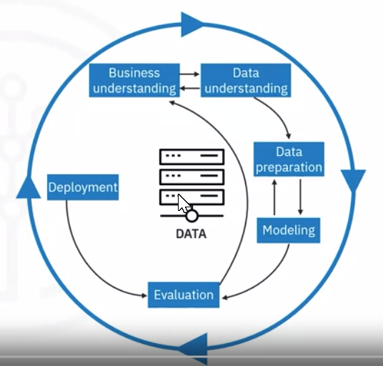

Story-Telling
- If you're trying to convince anyone to do anything with data, the first thing you have to do is tell a clear, a concise, compelling story.
- Developing a story for your dataset also improves your understanding of the data.
- Find a balance between telling a simple story and conveying the complexities of the data.
- Data storytelling is a structured approach for communicating data insights, and it involves a combination of three key elements: data, visuals, and narrative.

- Read the following article for understanding this:

https://www.forbes.com/sites/brentdykes/2016/03/31/data-storytelling-the-essential-data-science-skill-everyone-needs/?sh=745a073452ad

- People hear statistics, but they feel stories

- For some people, crafting a story around the data may seem like an unnecessary, time-consuming effort. They may feel the insights or facts should be sufficient to stand on their own as long as they’re reported in a clear manner. They may believe the revealed insights alone should influence the right decisions and drive their audience to act. Unfortunately, this point of view is based on the flawed assumption that business decisions are based solely on logic and reason.

Python for Data Science

Sets

- All set operations between 2 sets can be done by the following way:

set1_name.operation(set2_name)

- We can use the method set_index() to set any column of the Dataframe as an index. Or we can assign an external list as an Index to the Dataframe using its index attribute.

Data Analysis using Python

- Do not forget the method "value_counts" only works on pandas series, not pandas dataframes. As a result, we only include one bracket df['drive-wheels'] , not two brackets df[['drive-wheels']].

- Correlation does not imply causation. Determining correlation is much simpler the determining causation as causation may require independent experimentation.

- Regression is a statistical technique used for modeling the relationship between a dependent variable and one or more independent variables. The goal of regression analysis is to understand how the value of the dependent variable changes as the values of the independent variables change. It is widely used for prediction and forecasting.

- Correlation (Correlation Coefficient):
  - The correlation coefficient measures the strength and direction of a linear relationship between two variables. It is denoted by r and ranges from -1 to 1.
  - r = 1 indicates a perfect positive linear correlation.
  - r =−1 indicates a perfect negative linear correlation.
  - r = 0 indicates no linear correlation.
- Coefficient of Determination (R-squared):

- The coefficient of determination, often denoted as R², represents the proportion of the variance in the dependent variable that is predictable from the independent variable(s).
- R² is a measure of how well the variation in the dependent variable (Y) can be explained by the independent variable(s) (X).
- R² ranges from 0 to 1, where 0 indicates that the model does not explain any variance, and 1 indicates that the model explains all the variance.
- While both correlation and R² provide information about the relationship between variables, R² specifically focuses on the explanatory power of a regression model. In simple linear regression, the square of the correlation coefficient (r²⁾ is equal to R²
- R²=r²
- Be alert to situations where your R-squared value might be negative, which can indicate overfitting.
- In multiple linear regression, R² can be interpreted as the proportion of the variance in the dependent variable explained by all the independent variables together. Correlation, on the other hand, specifically measures the linear association between two variables.

INTRODUCTION TO MACHINE LEARNING

- Definition:-

- Machine learning is the subfield of computer science that gives "computers the ability to learn without being explicitly programmed.”

